Make and Create Arts
Photography Quiz! Tutor: Megan
Use the photography refresher sheet to help you answer these questions if you get stuck!

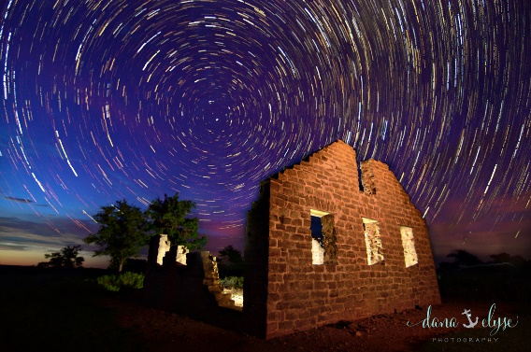
- Which one of these images was taken with a fast shutter speed?
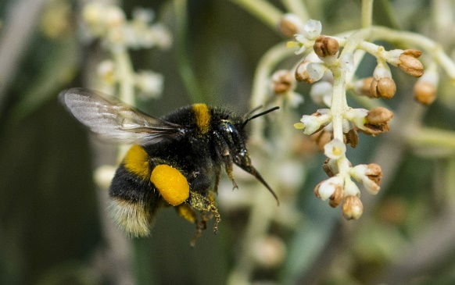
A)
B)

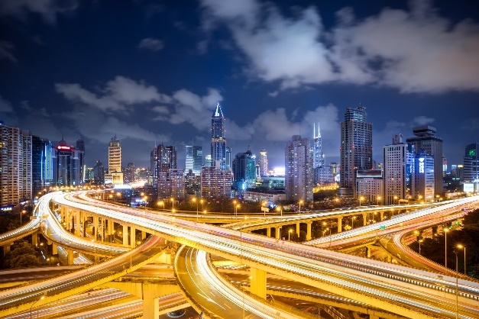
C)
Answer:

- Which one of these images was taken with a slow shutter speed?
B)
A)

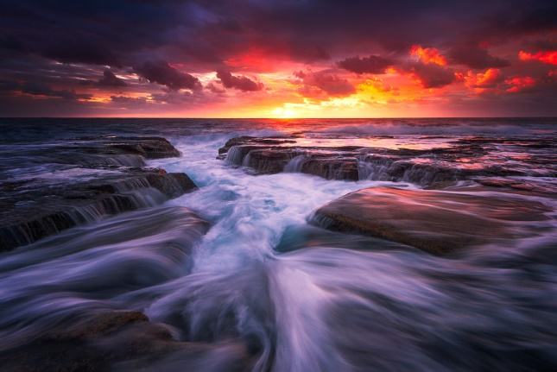
C)
Answer:
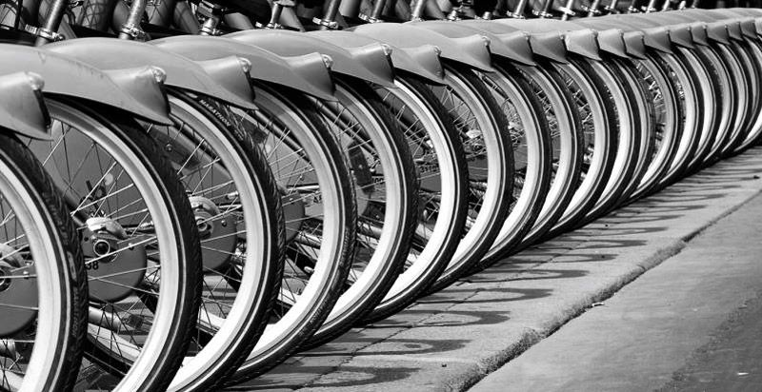
- What kind of depth of field was used in this image? Shallow or extensive?
Answer:

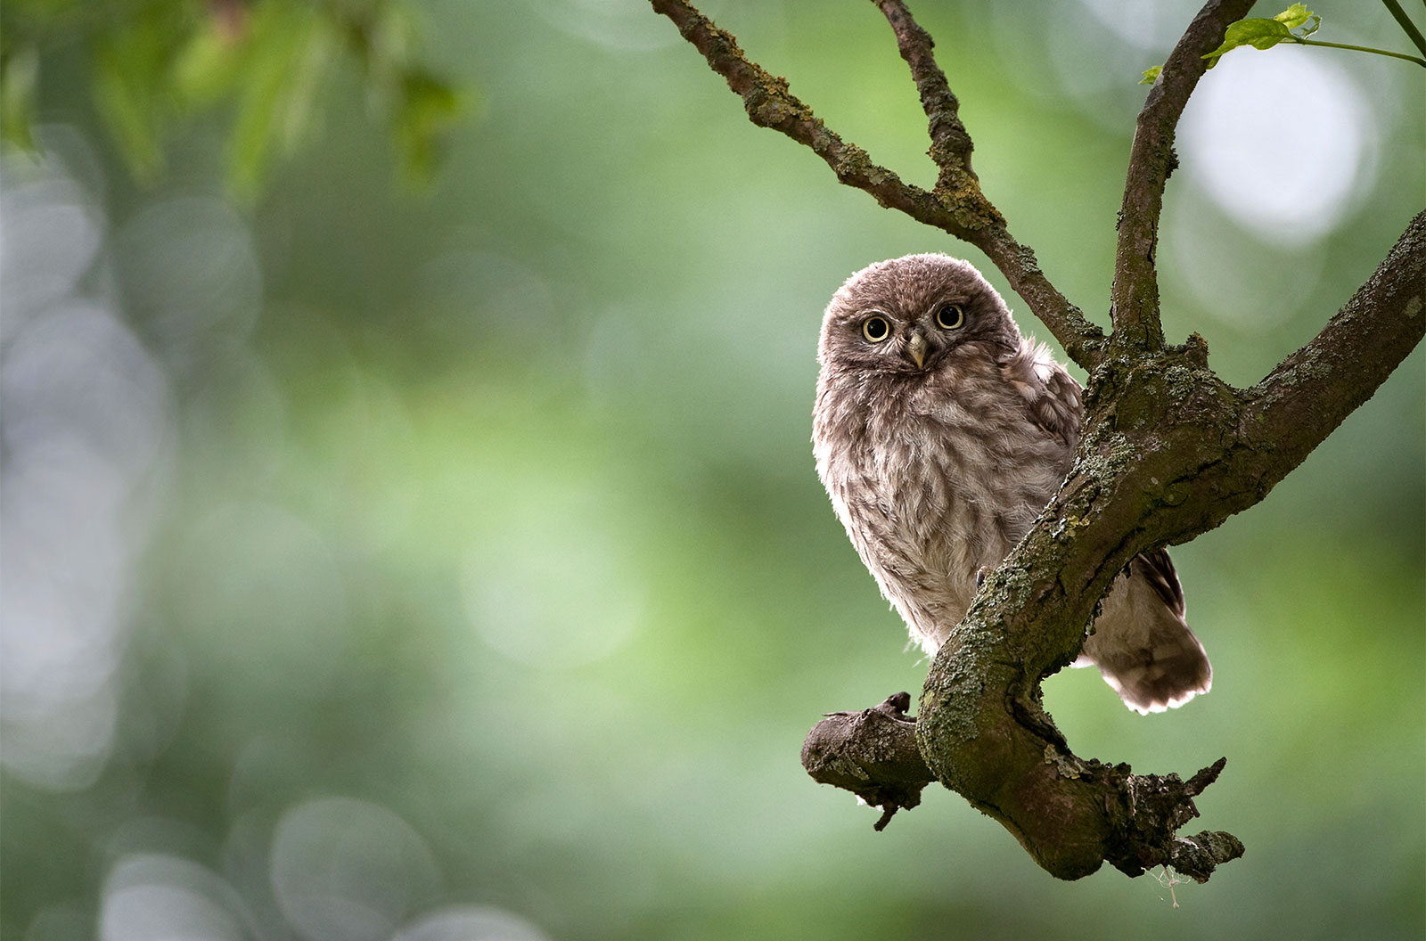
- What kind of depth of field was used in this image? Shallow or extensive?
Answer:
- What technique did the photographer use to take this landscape image?
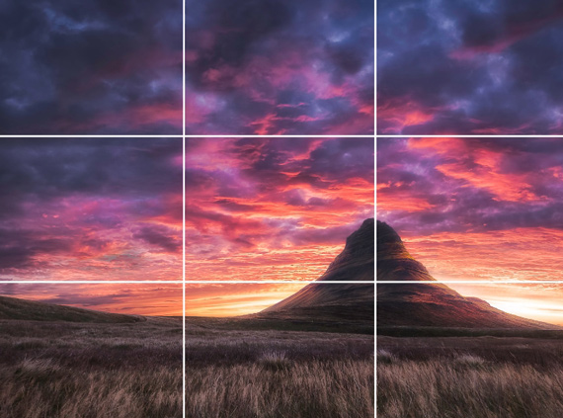

Answer:

- What technique was used here?
- Negative space
- Framing
- Leading lines

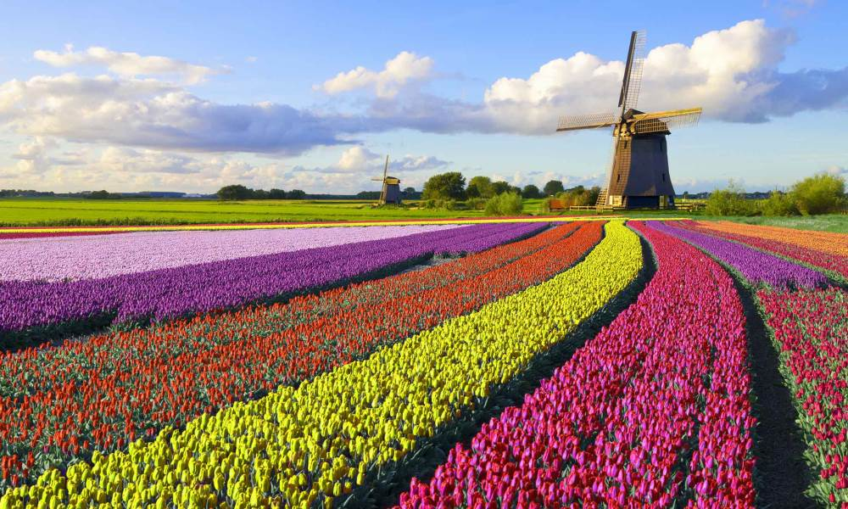
Answer:

- Can you state an example shutter speed setting you think would be used to freeze motion in an image?
Answer:

- Can you state an example aperturesettingyou think would be used create a shallow depth of field in an image?

Answer:

- Can you name 5 types of photography?
1.
2.
3.
4.
5.

- What three settings are used to make up the exposure triangle?
1.
2.
3.

