Make and Create Arts
Photography Refresher
Tutor: Megan Sharpe

Basics
- Three golden rules of photography
- 1. Everything halves and doubles
- 2. What you gain in one hand you lose in another
- 3. Never hand hold a camera below 1/60 shutter speed without a tripod

Settings
F- numbers (aperture)
- 1.8, 2.8, 4, 5.6, 8, 11, 16, 22, 32
Shutter speed
- 1 second
- ½ second
- ¼ second
- 1/8 second
- 1/15 second
- 1/30 second
- 1/60 second
- 1/125 second
- 1/250 second
- 1/500 second
ISO
- 100, 200, 400, 800, 1600, 3200, 6400 (how sensitive the camera is to light)

Types of Photography
- Portraiture
- Still life
- Landscape
- Street photography
- Sports photography
- Architecture photography
- Wildlife photography
- Advertising
- Photojournalism
- Documentary
- Fashion

- Night photography
- Social photography
- Event photography
- Macro photography
- Close up photography
- Stock photography
- Music photography
- Food photography
Exposure Triangle

Light is needed for an image to exist, ISO, Shutter Speed and Aperture are all related to how light makes up the exposure of the image.
These three settings make up an images exposure!

Camera Settings

Aperture/ depth of field
A shallow depth of field means that only a select few things will be in focus and the rest of the image will be out of focus (blurry). The smaller the F-number is the wider the aperture will be, this gives you a shallow depth of field.

- F1.8
- F2.8
Examples of wide apertures (used for a shallow depth of field)
- F4
- F5.6

An extensive depth of field means that everything in the image will be in focus. The bigger the F-number is the narrower the aperture will be, creating a large or extensive depth of field.

- F16
Examples of narrow apertures (used for an extensive depth of field)
- F22
- F32

Examples below
Shallow Depth of Field (f1.8)

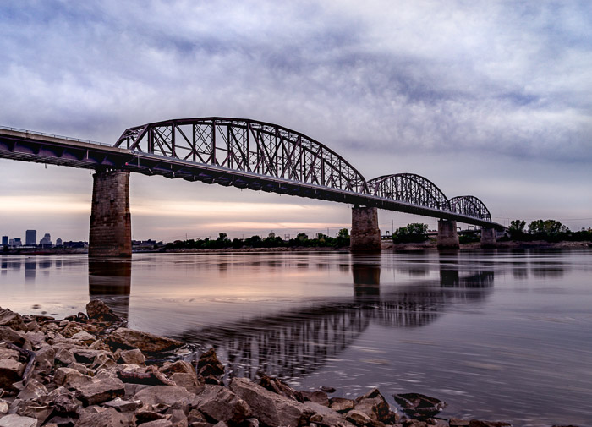
Extensive Depth of Field (f22)

Shutter Speed
A fast shutter speed means that all motion will be frozen, the faster the shutter speed (shorter the fraction of a second) means the camera will take the image faster.

- 1/125 second
Examples of fastShutter Speeds (used to freeze motion)
- 1/250 second
- 1/500 second
- 1/1000 second

A slow shutter speed means that any motion in the image will be blurred. The slower the shutter speed (the longer the fraction of a second or the longer the exposure time- full seconds) means the camera will take an image slower.

- 30 seconds
- ↓
- 1 second
- ½ second
Examples of slow Shutter Speeds (used to blur motion)
- ¼ second
- 1/8 second
- 1/15 second
- 1/30 second
Examples below
Slow Shutter Speed (30 seconds)
Fast Shutter Speed (1/2000 second)
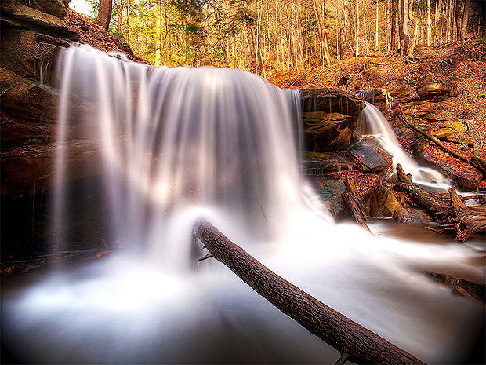
Composition

- Composition is what the subject matter of an image is and how it is made up.
Things to consider in an image:
- Inspiration
- Mood
- Depth of field
- Rule of thirds
- Pose
- Clothing
- Background/foreground
- Props
- Postproduction
- What you like/ don’t like about what’s in your frame and how can you fix it?
- Colours
- Shapes
- Arrangement
- Texture
- Camera settings
- Time of day
- Cropping
- Angles

Rule of Thirds
Rule of thirds is the practice of dividing your image up into an imaginary grid with 2 vertical lines and 2 horizontal lines. You want to put the most important parts of your image on these lines or the cross sections. Things like horizons, eyes, structures, and important subject matter. Your subject matter could also be placed within the boxes/ rectangles created by the lines.

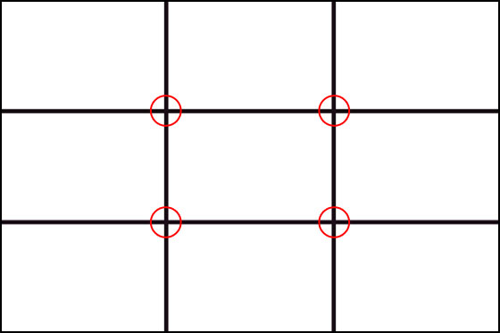

Rule of Thirds examples
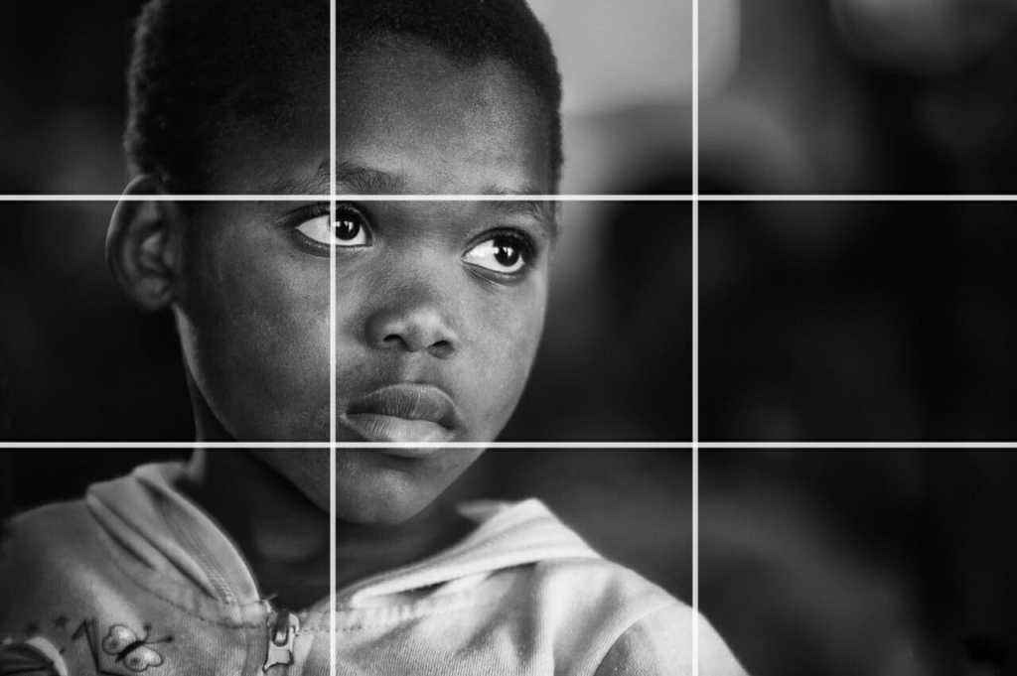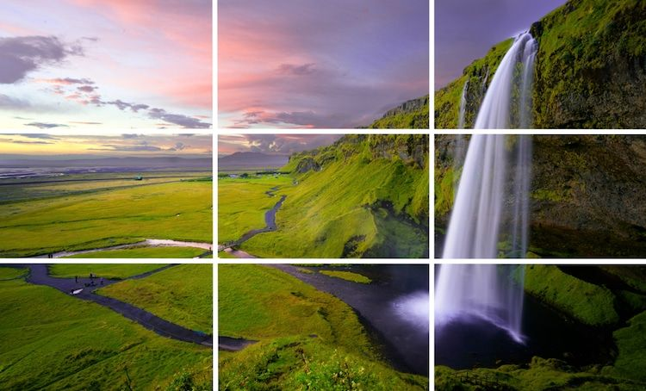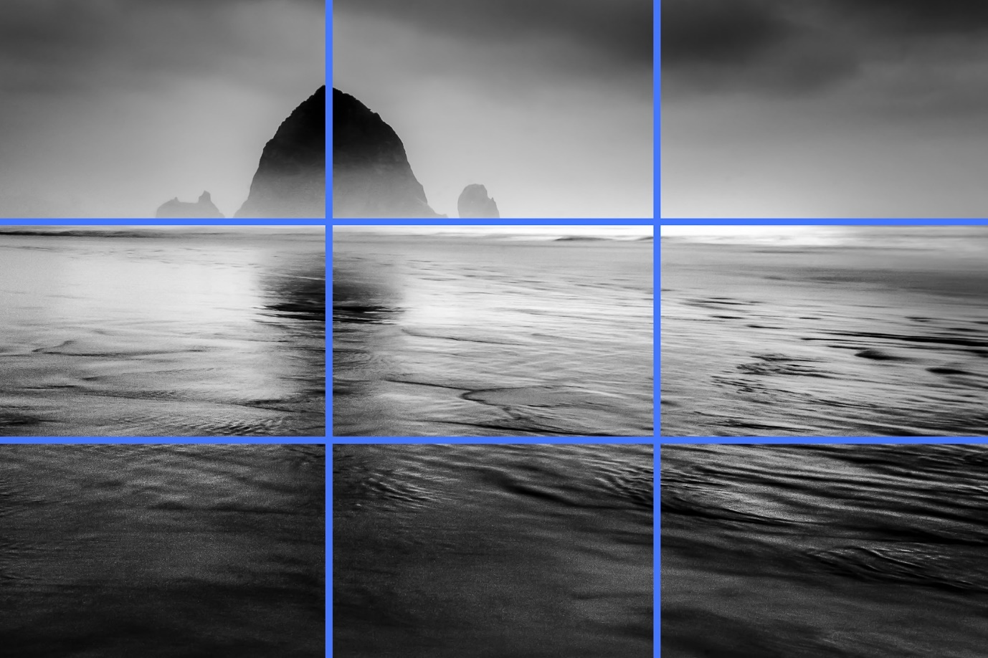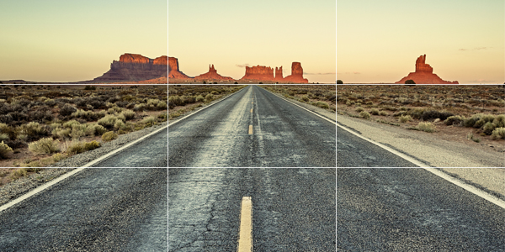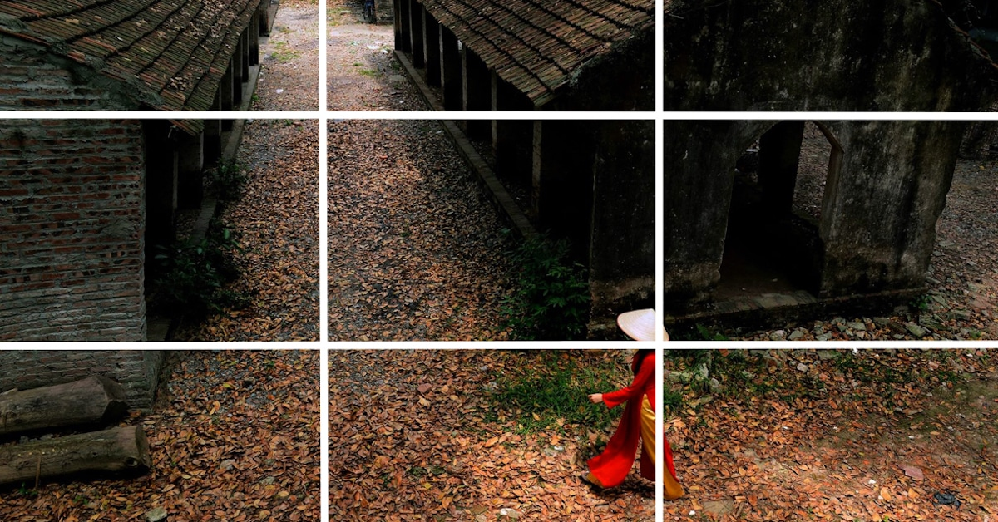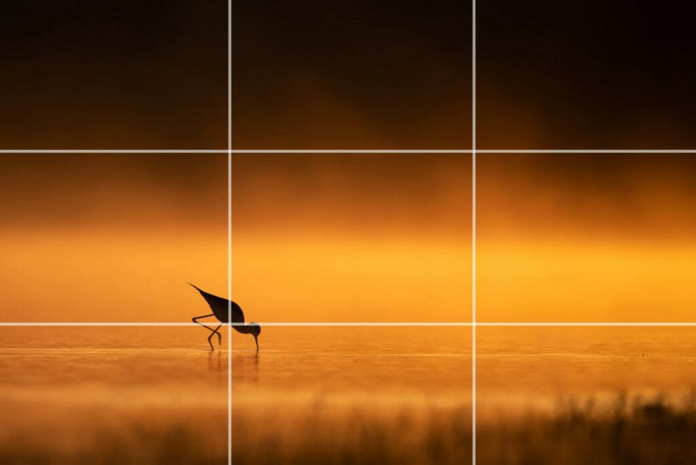

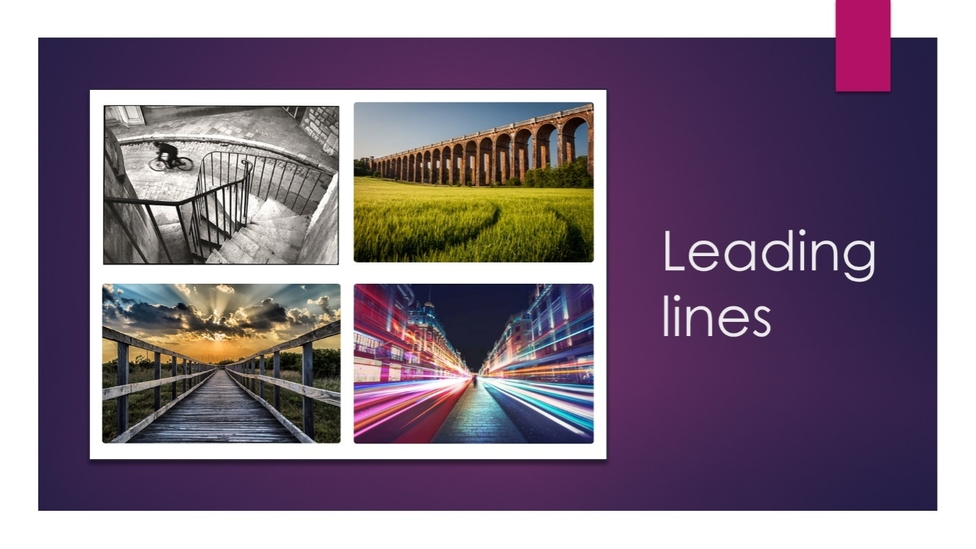
Other basic camera techniques
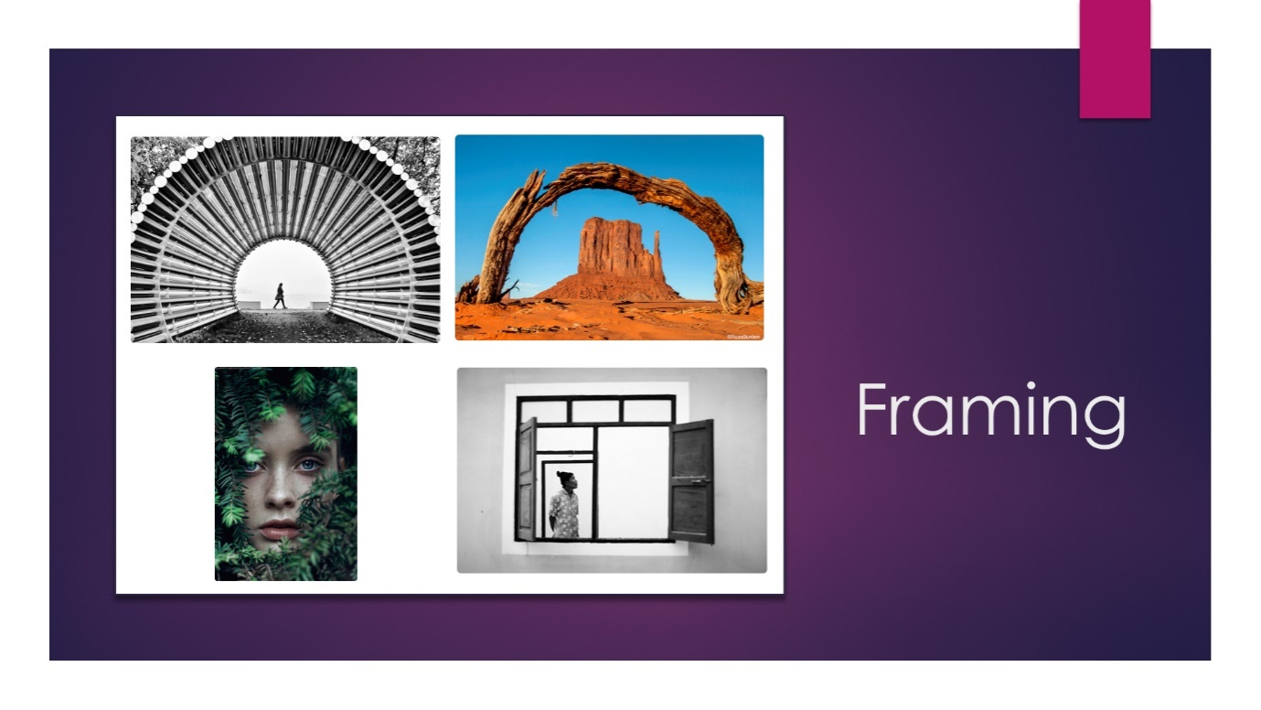
- Leading lines is the technique of using or creating lines in the frame that lead the eye around or into the image and can be used to point to important subject matter or to draw you further into the photograph.
- Framing is a technique use to make an image more interesting by using natural occurrences, man-made structures, or props to frame your subject.

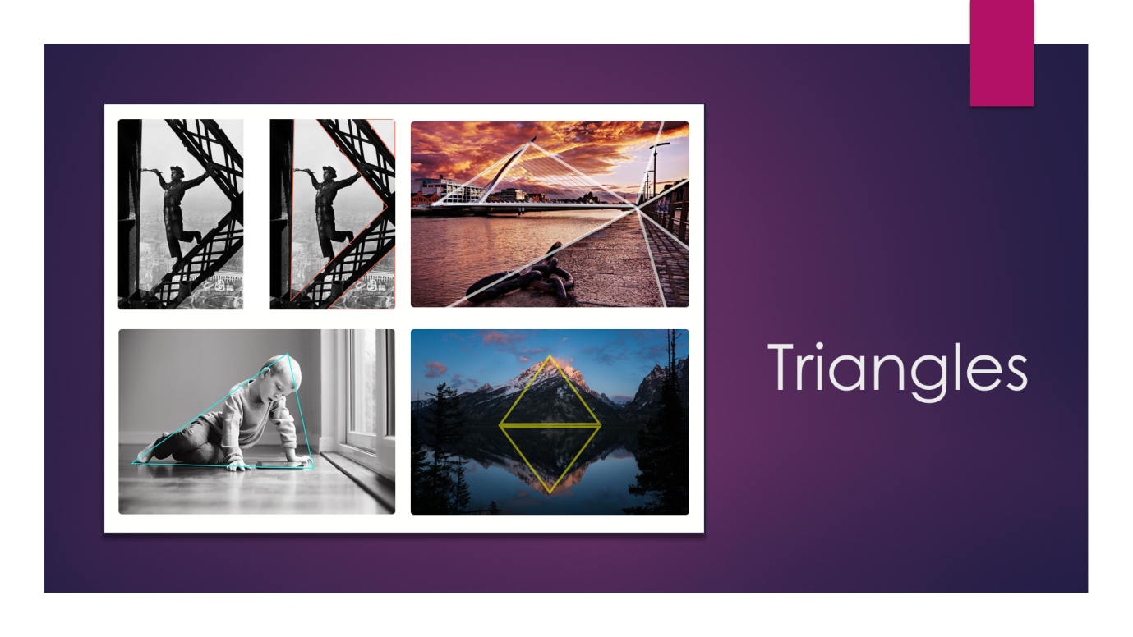

- Triangles are very pleasing to the eye, try to find or make triangles in your images, these can also act as leading lines. If creating a still life image try and arrange your props into to points of a triangle.
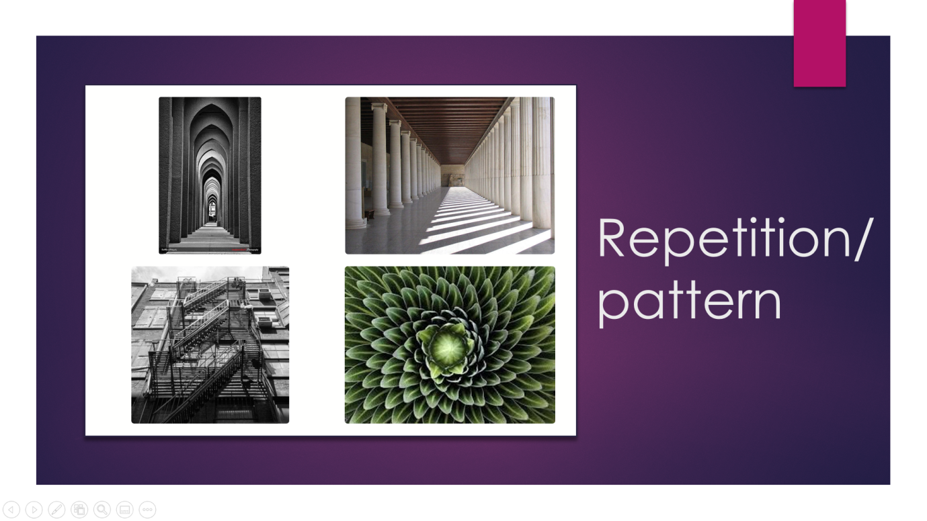

- Again, repetition is very pleasing to the eye, this can be easily found in plants and building structures.

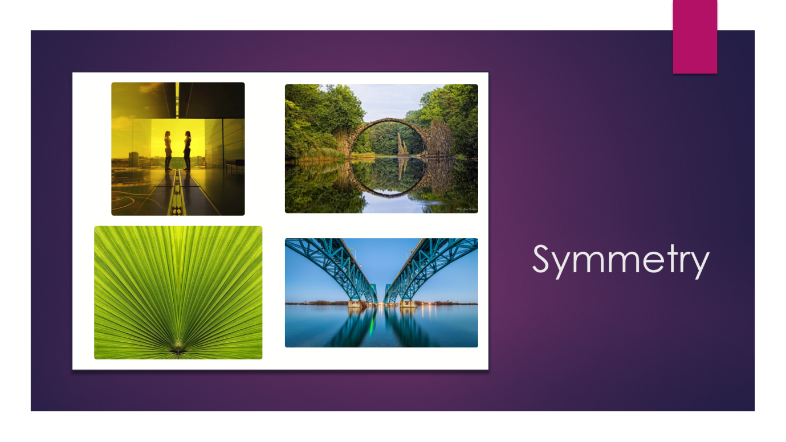
- Using symmetry in an image can be highly effective in an image. This can be created using reflections, in nature or in structures.
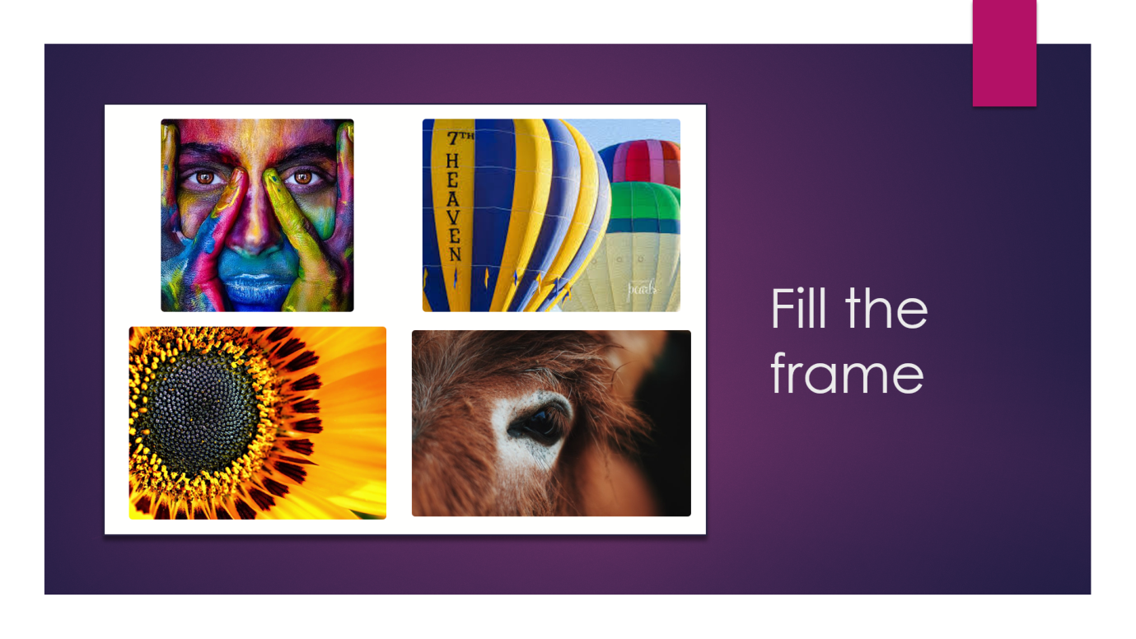
- Filling the frame with your subject matter means that the eye will not be distracted by other things that could be in the frame. This also means that the small details of subject can be seen more easily.

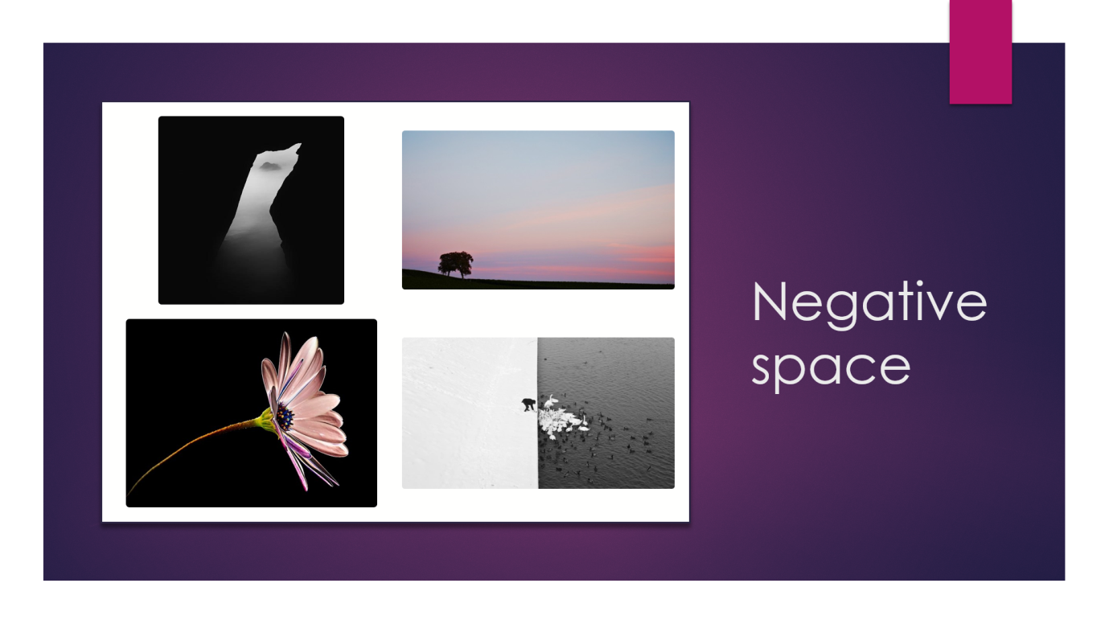

- Negative space can be seen as the opposite of fill the frame. Negative space can be effective in isolating the subject. This is generally used with a solid colour background.

Still Life
Techniques to consider in a Still Life
- Rule of thirds
- Triangles
- Shapes
- Colours
- Textures
- Inspiration
- Depth of field
- Props

Examples of Still Life

Portraiture
Techniques to consider in Portraiture
- Colours
- Textures
- Angles
- Inspiration
- Mood
- Camera settings
- Framing
- Triangles
- Rule of Thirds
- Props
- Fill the frame
- Negative space
- Depth of field
- Pose
Examples of portraiture

